24.58: a)

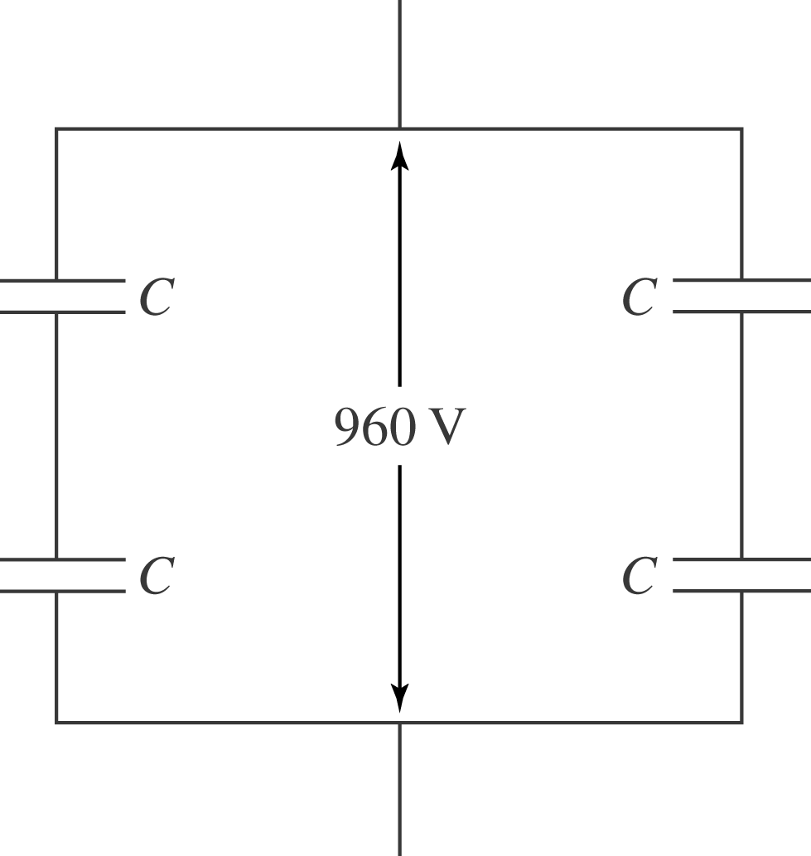

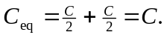 So the total capacitance is the same as each individual capacitor, and the voltage is spilt over each so that  V. Another solution is two capacitors in parallel that are in series with two others in parallel.

b) If one capacitor is a moderately good conductor, then it can be treated as a “short” and thus removed from the circuit, and one capacitor will have greater than 600 V over it.

